CSA05-DATABASE MANAGEMENT SYSTEMS
LAB MANUAL

DDL Commands – CREATE, ALTER, DROP

Questions:
- Create a table name STUDENT with following structure.

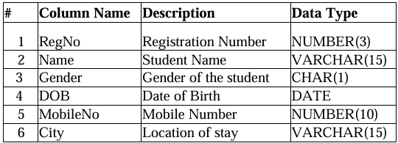

Query:

Use database;
Create table students(regno int (3),name varchar(15),gender char(1),dob int(10),mobileno int(10),city varchar(15));

Output:

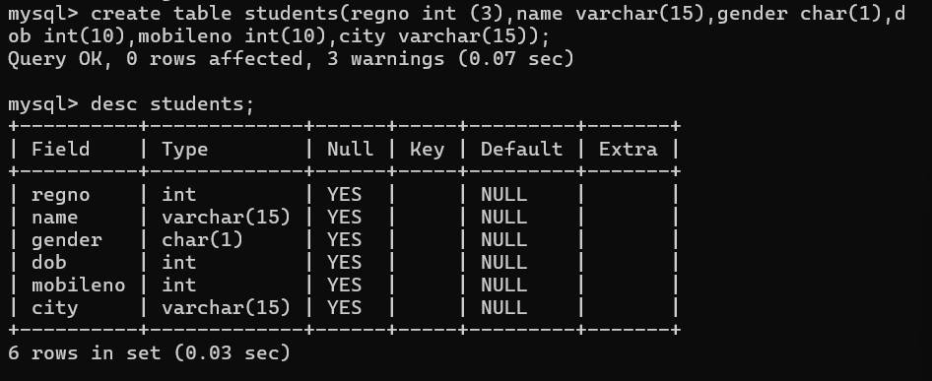

- Create a table name FACULTY with following structure.

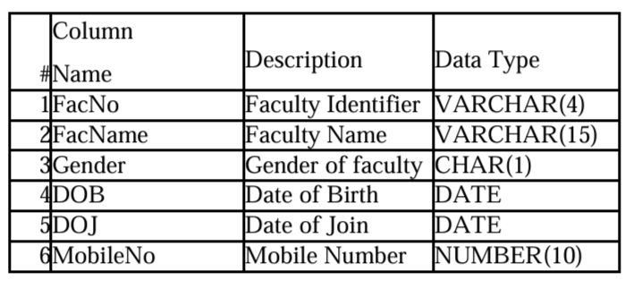
Query:

Use database;
create table faculty(facno int(4),facname varchar(15),gender char(1),dob int(10),doj int(10),mobileno int(10));

Output:
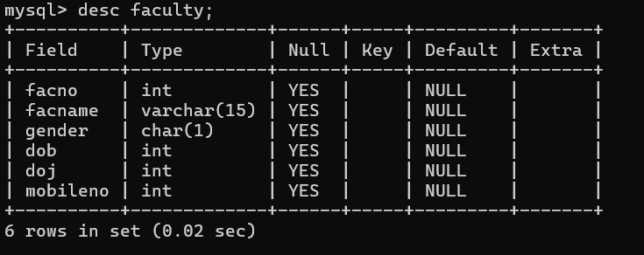

- Create a table name DEPARTMENT with following structure.

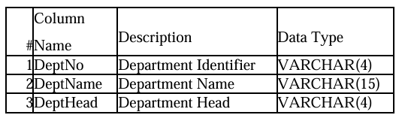

Query:

create table department(deptno int(4),deptname varchar(15),depthead varchar(15));

Output:

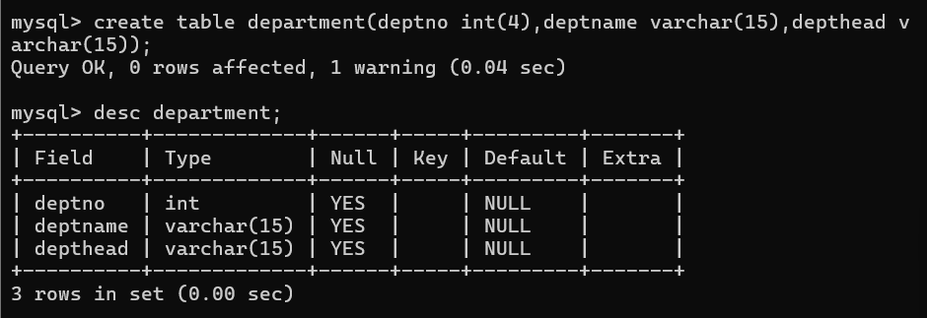

- Create a table name COURSE with following structure.

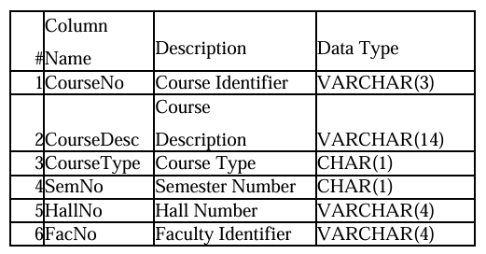

Query:

create table course(courseno int(5),coursedesc varchar(15),coursetype char(5),semno int(5),hallno int(5),facno int(5));

Output:

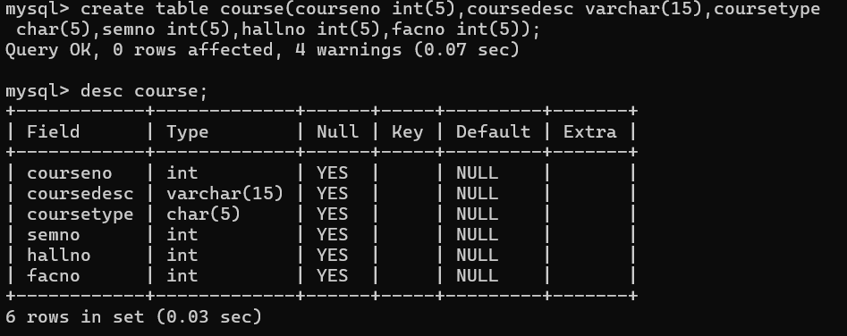

5) Modify the table FACULTY by adding a column name Dept of datatype VARCHAR(10)

Query:

alter table faculty add dept char(10);
Query OK, 0 rows affected (0.07 sec)

Output:

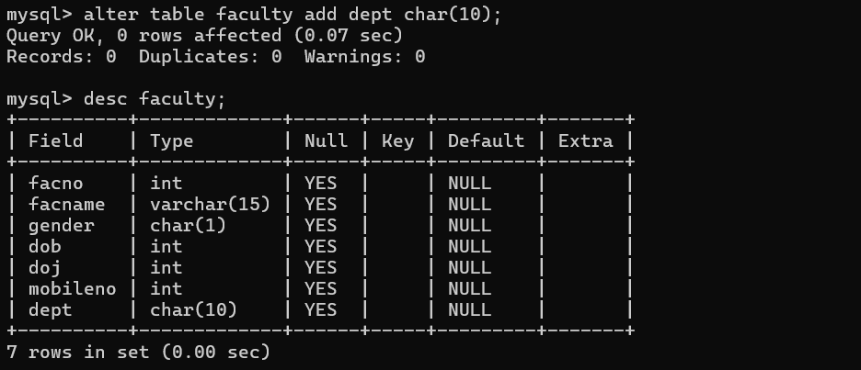

RESULT:

Tables are created, altered and modified using DDL commands.

